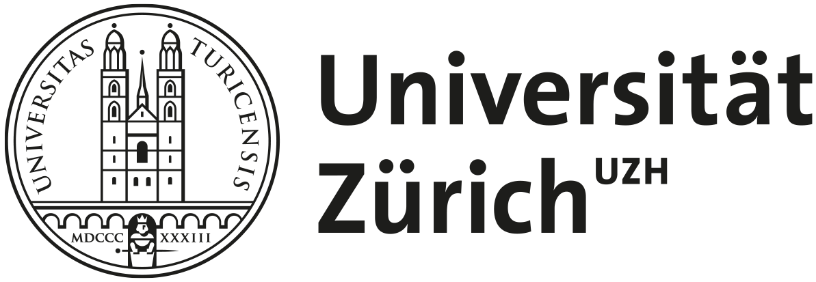

Invitation to participate as a guest student in the seminar
«Understanding and Preventing Ageism»
In Fall semester 2024, we are offering an English-language course for Master's students at the University of Zurich on “Understanding and Preventing Ageism: Research, Innovation and Policy Considerations”.
Guest participants aged 55+ are also welcome - we cordially invite you to participate in the course free of charge!

Format: Online seminar for Master's students of psychology and interested guest participants (max. 25 participants)
Time frame: 18.09.2024 – 18.12.2024
Time required: Approx. 4 hours / week
Course language: English
Course instructor: Dr. Burcu Demiray

Content:
- Introduction to ageism: definitions, conceptualization, psychological theories
- How to study ageism: Methodologies
- Examination of the effects of ageism in different areas of society (e.g., workplace, healthcare and artificial intelligence)
- Interventions against ageism: Innovation and policy recommendations

Course Outline:
- Interactive discussion sessions online (Zoom meetings): Every Wednesday between 10:15 – 11:15 (CET)
- Weekly preparation on the e-learning platform of the University of Zurich: Watching e-learning videos, solving tasks, and reading scientific literature

Information for guest participants:
- The course is free of charge for guest participants.
- In order to ensure an ideal learning environment, regular and committed participation in the course is required.
- Active contribution in the discussion sessions (via Zoom meetings) is encouraged.
- There is no examination.

Contact for questions or further information: miriampaula.wallimann@uzh.ch

